HTTP/1.1 vs HTTP/2

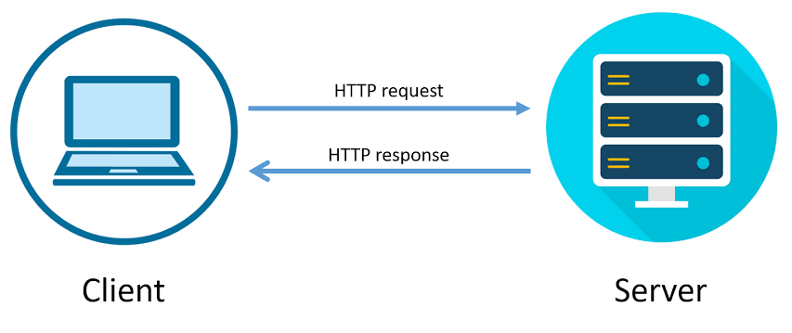HTTP stands for Hypertext Transfer Protocol, which is a protocol for transferring data over the web and it is the basis for almost all web applications. More specifically, HTTP is the method computers and servers use to request and send information.

HTTP is a client-server protocol, which means that it involves communication between a client (such as a web browser or mobile app) and a server (which hosts the website or web application). The client sends an HTTP request to the server, which then sends an HTTP response back to the client. The response contains the requested data or resource, such as a web page, image, or video.

In this blog we are going to see about Difference Between HTTP 1.1 vs HTTP 2.

|  |  |  |
| --- | --- | --- |
| VERSION | HTTP 1.1 | HTTP 2 |
| Intro’s : | The first usable version of HTTP was created in 1997, this first version of HTTP was called HTTP/1.1. | HTTPS 2 was created in 2015 to solve several problems that the creators of HTTP/1.1 |
| Protocol: | Text-Based Protocol:  It works on the textual format, human-readable, which isn't as efficient for machines. | Binary Protocol:  It works on the binary protocol, only binary commands in the form of 0s and 1s are transmitted over the wire. |
| Multiplexing: | HTTP/1.1 loads resources one after the other, so if one resource cannot be loaded, it blocks all the other resources behind it. | HTTP/2 is able to use a single TCP connection to send multiple streams of data at once so that no one resource blocks any other resource. |
| Resource Retrieval: | Resources are requested and delivered sequentially, leading to potential delays in loading web pages. | Supports parallel resource retrieval, reducing latency and improving web page loading times. |
| Compression: | It compresses data by itself, which can increase data transfer size. | It uses HPACK for data compression which can speed up the transfer. |
| Server Control: | Server only serves content to a client device if the client asks for it. | HTTP/2 solves this problem by allowing a server to "push" content to a client before the client asks for it. |
| Resource Prioritization: | Resources are fetched without a clear priority, potentially causing critical resources to be delayed by non-critical ones. | Supports resource prioritization, ensuring that critical resources are delivered first. |
| Browser Support: | Older browsers may not fully support HTTP/1.1 features, which lacks and impacting performance. | Most modern browsers support HTTP/2, ensuring widespread adoption. |
| Response Time: | It uses multiple TCP connections are essential so response time was bit high comparing with HTTP/2 | It uses only single TCP to ensure fastest Response time. |
| Compatibility: | HTTP/1.1 is backward compatible with older HTTP/1.0, ensuring compatibility with legacy systems. | Represents a significant step in the evolution of HTTP, with ongoing improvements and refinements in the pipeline. |
| TLS encryption: | It is optional in this version. | Its mandatory in HTTP/2. |

Overall, the evolution of HTTP has been driven by the need to improve the performance, efficiency, and security of web communication. Each version has addressed the limitations of the previous version, and it is expected to continue this trend by providing even better performance and security.

* **Balaji Nagarajan**